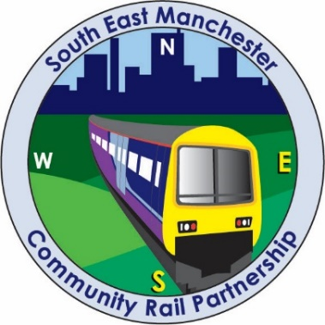

**Introduction**

South East Manchester, Crewe to Manchester and Mid Cheshire Community Rail Partnerships are working together to bring a community art project to the Edgeley Approach at Stockport Station.

Whilst this is a busy thoroughfare with a high daily footfall, this side of the station has seen little development compared to the main entrance.

Supported by Avanti West Coast and Network Rail, the art project will see an exhibition of up to 40 artworks displayed along the historic wall, each framed within a train window designed by local artist, Eamonn Murphy.

Schools, Colleges, Community groups and individual artists are now invited to submit artwork for long term display at the station.

**Artistic brief - views through the train window**

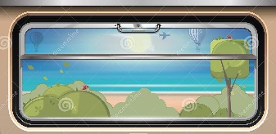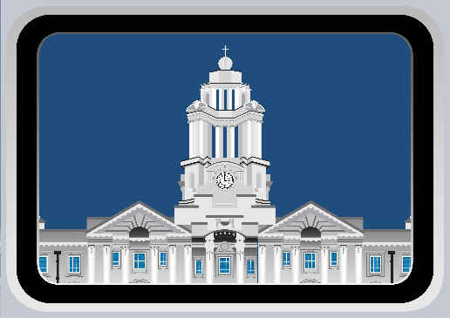

Artists are invited to create a design which will show the view from a train window. The design can have a theme of either **landscapes**, **cityscapes** or **people** and could feature members of the community including community groups, past and present, historical events/features of Stockport, or destinations which are connected by the railway, celebrating the landscape, buildings and dynamism of the areas, or bring together a combination of these themes.

The size of the final printed artwork will be approximately **260cm in width by 80 cm** in height and art submissions in this size are ideal. Artwork submitted in a smaller format can be scaled up from no less than 50% of this size, however smaller images will result in a lower quality final image. Please note: artwork may be trimmed to fit the varying size requirements.

For landscape inspiration, you can see our three partnership areas and destinations that can be reached from Stockport at the following links: -

* [Crewe to Manchester](http://www.crewe2manchesterrail.org.uk/)
* [Mid Cheshire](https://www.midcheshirerail.org.uk/)
* [South East Manchester](http://www.semcorp.org.uk/explore-the-lines/)

Here are some further potential sources of inspiration for artworks, although all ideas which fit with the above themes are welcome: -

* The work of L.S. Lowry is revered for presenting the Greater Manchester area to the world and Stockport was a regular feature in the artist’s work. This means that many people would be able to identify some of the more famous locations in Stockport without having ever visited the area. Alan Lowndes is another artist that has drawn on Stockport for influence over the years.
* It is believed that local hat makers Christie provided hats for Indiana Jones, The Avengers and James Bond.
* The poem, ‘From a railway carriage’, by Robert Louis Stevenson. See [link](https://www.familyfriendpoems.com/poem/from-a-railway-carriage-by-robert-louis-stevenson) for poem.
* The story of John Axon, who was a train driver from Edgeley. There is a plaque on Stockport Station over his actions during a train crash. Ewan MacColl created a musical piece called the Ballad of John Axon [Ewan MacColl – The Ballad of John Axon Lyrics | Genius Lyrics](https://eur01.safelinks.protection.outlook.com/?url=https%3A%2F%2Fgenius.com%2FEwan-maccoll-the-ballad-of-john-axon-lyrics%23%3A~%3Atext%3DThe%2520Ballad%2520of%2520John%2520Axon%2520Ewan%2520MacColl%2520On%2Cwhen%2520the%2520automatic%2520stream%2520brake%2520pipe%2520in%2520his&data=04%7C01%7Csarah.f.morgan%40stockport.gov.uk%7Cf029b85fbcde4cf76f6208d9d4fa1152%7Ca05ef69e61494fbaa40cdf338810f644%7C0%7C0%7C637774992761836896%7CUnknown%7CTWFpbGZsb3d8eyJWIjoiMC4wLjAwMDAiLCJQIjoiV2luMzIiLCJBTiI6Ik1haWwiLCJXVCI6Mn0%3D%7C3000&sdata=0TGrUtjzbccIy1nxUVo6yDHAnIl%2F8cBZGqehM0d0U5E%3D&reserved=0)

Avanti’s Artwork Guidance document will be provided with this brief and artists and art co-ordinators are encouraged to read this before formulating their design.

**Process for artwork submission and selection**

**End Nov 2022** Photographs of artwork should be submitted by email to [communityrail@stockport.gov.uk](mailto:communityrail@stockport.gov.uk) with a brief description of the design, along with the full name, postcode and contact number for the entrant. We also encourage artists to submit their own videos and photographs of the artwork creation.

**Dec 2022 / Jan 2023** From the submitted entries, the selection panel will select up to 40 pieces of artwork. Artworks will be stored digitally, and original pieces will be retained by the entrant. Winners will be notified by email.

The final artworks will be printed and installed at Stockport station by Network Rail, with winners being invited to an official opening. The date will be confirmed nearer the time.

**Guidelines for artists**

* Depending on the number of submissions, priority may be given to Stockport based artists/groups within a 1.5-mile radius of the station. See link to prioritised postcodes (area maps are available on request): Prioritised postcodes for Edgeley Art Competition 2022
* The decision of the selection panel will be final.
* In entering the competition, artists agree that submitted artworks may also be used by the Community Rail Partnerships, for the promotion of the project and work of the Community Rail Partnerships, and by its stakeholders and funders (in printed and digital formats). The artists retain the rights to the original unframed artwork.
* The artwork will be installed at Stockport station on a long-term basis.
* No financial prize is available.

These details can also be found on the website:

[www.crewe2manchesterrail.org.uk/stockportedgeleyartproject](http://www.crewe2manchesterrail.org.uk/stockportedgeleyartproject)